**Assignment1**

Write a program which accepts a sequence of comma-separated numbers from console and generate a list.

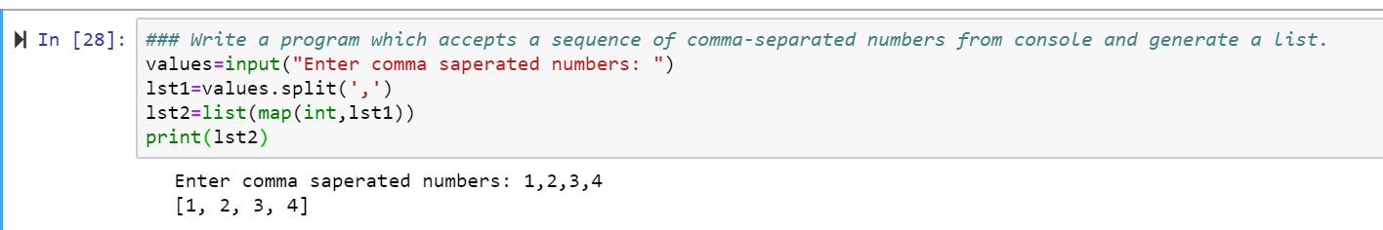

**Assignment2**

Create the below pattern using nested for loop in Python.

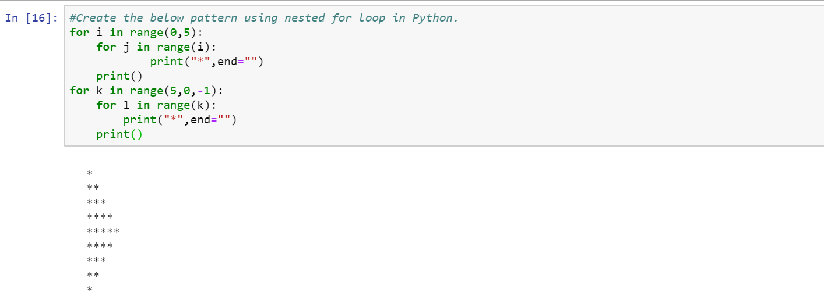

**Assignment3**

Write a Python program to reverse a word after accepting the input from the user.

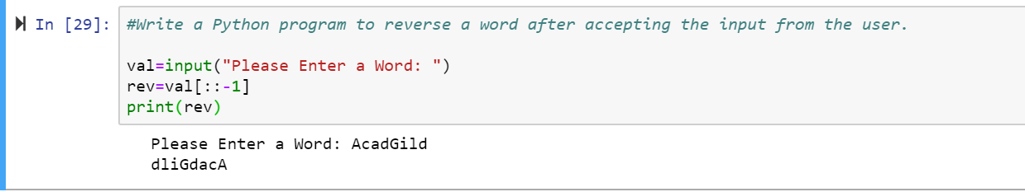

Write a Python Program to print the given string in the format specified in the sample output.

